2022-23 Season 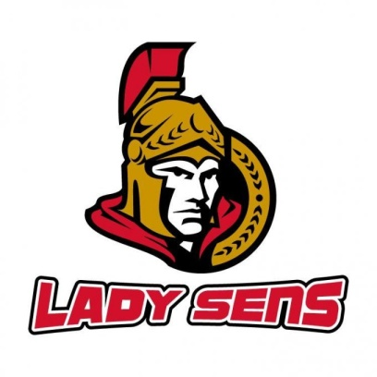

House League Coach Application
All fields on the application are to be filled.

Date Completed

Name

Coach Certification Number (mandatory)

Telephone number

Email address

Home address

KGHA players associated with you
Player’s name | Birth year | Age Group of Team for 2022-23
Add more rows to table as necessary.

Coaching interests for 2022-23 (if unsure, please indicate may apply)
Team and age level | Will apply | Head coach | Assistant coach
Add more rows to table as necessary.

Coach Certifications: Please provide a copy of your coach certification with your application.
Certificate/Course | Date of Training/Course | Year Certified (if applicable)
Add more rows to table as necessary.

Coach Experience – Hockey
Role | Team level | Organization | Season
Add more rows to table as necessary.

Coach experience – other sports
Role | Team level | Sport | Organization | Season
Add more rows to table as necessary.

Non-Coach Hockey Experience
Role | Team level | Organization | Season

Other instruction experience
Role | Recipient age/level | Organization | Years
Add more rows to table as necessary.

Organized hockey player experience
Level of play | Association/league | Years
Add more rows to table as necessary.

COACHING ASPIRATIONS

Short Term Goals:

Long Term Goals:
.

List three coaching skill areas you consider to be your strengths:
1.
2.
3.

List three coaching skill areas you wish to improve:
1.
2.
3.

other (anything else you want us to have on record or makes you a better coach like other volunteer work, work with youth, special and relevant qualifications, professional accreditations, related employment, education and previous coaching awards and/or results):

General Information Guidelines
Please review the following information.

- Coaches are responsible to ensure the KGHA, OWHA and HOCKEY CANADA constitutions, by-laws, policies, and guidance are understood and abided by.

2) All coaches are to abide by the KGHA coach dress code policy and are to ensure that their players abide by the player dress code. KGHA merchandise must be approved by the Association and can only be purchased from authorised dealers.

3) Coaches may be requested to meet with executive members throughout the season. Coaches are required to attend such meetings or other specified events and activities as directed by the executive.

4) All teams are required to participate in their respective KGHA Tournament. Also, all teams are required to participate in a tournament selected by the Association. Coaches can select the other appropriate tournaments for their teams.

5) All coaching applicants are requested to supply a copy of their NCCP certification with the application.

6) All players and team staff – assistant coaches, trainers, managers, on-ice help - must be approved by the Vice-President House prior to being on the roster.

7) Managers and Coaches are responsible for managing their team personnel’s, players’ and parents’ conduct.

8) All House teams will have a maximum of 16 skaters and 2 goalies.

9) All applications will be reviewed and references will be contacted. We thank all applicants for their interest, but only those selected for an interview will be contacted.

By submitting this application, I acknowledge that I have read and understood the information above and I agree to abide by the information guidelines and all KGHA policies.

Name:

